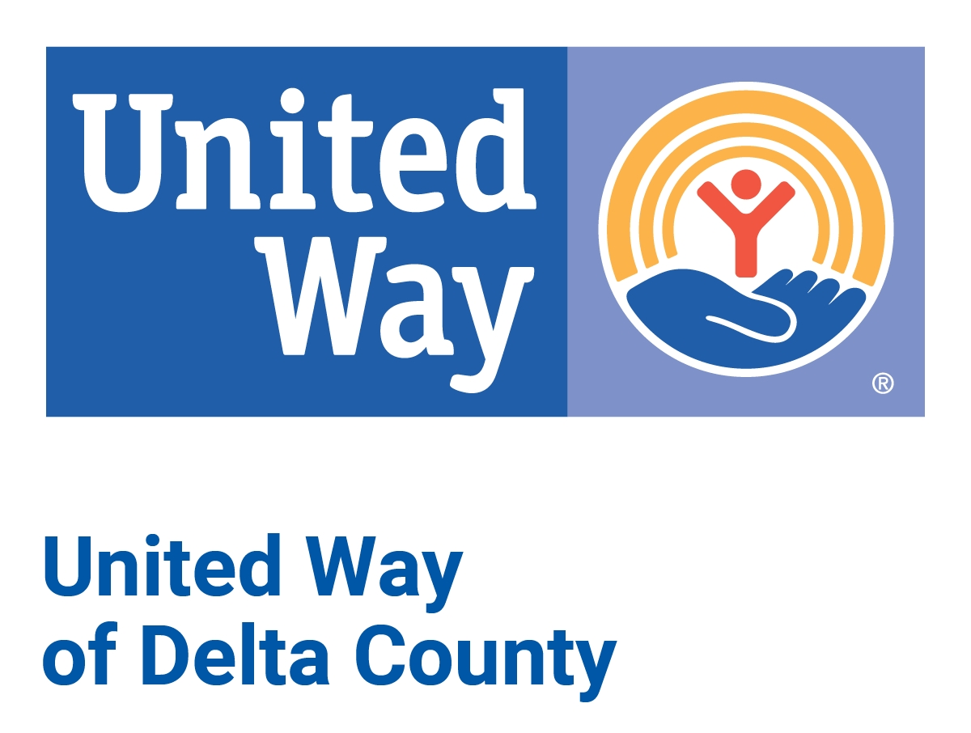

Mission

The mission of the United Way of Delta County is to improve our community’s capacity to care for one another.

Vision

To do this, we will:

- Energize and inspire people to make a difference.

- Build coalitions around the community agenda.

- Diversify our own development efforts and support those of others.

- Measure, communicate, and learn from the impact of our efforts.

