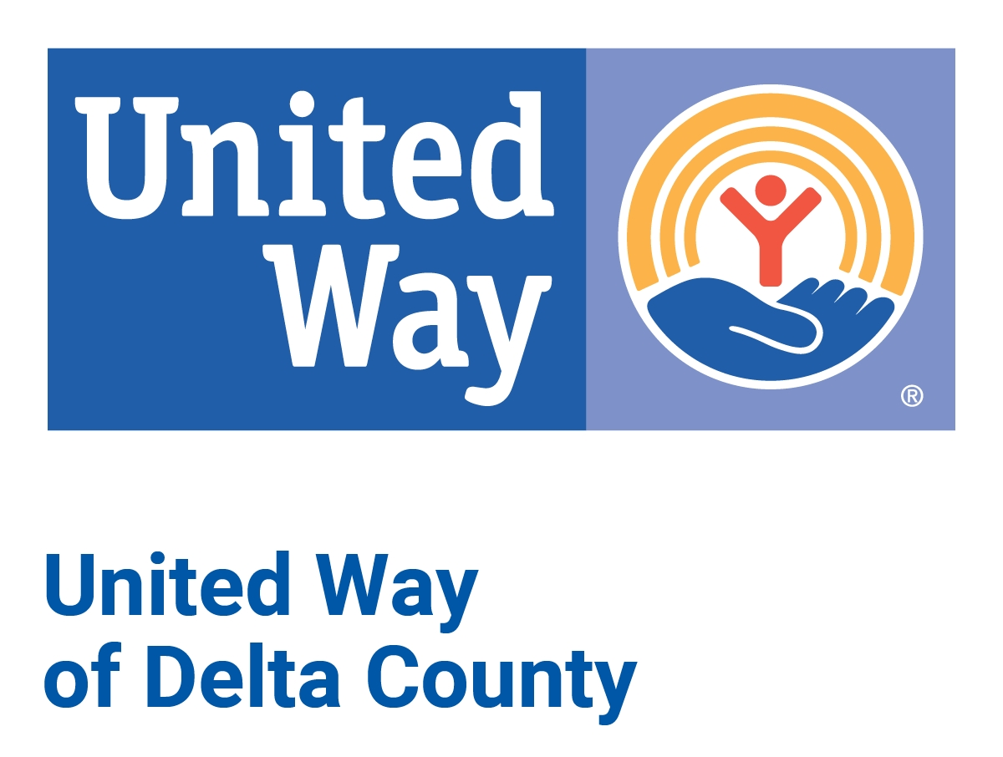

Board Member Application

Date:
Name:
Mailing Address
City, State, Zip
□ Home □ Work □ Cell
Primary Phone ( )
□ Home □ Work □ Cell
Secondary Phone ( )
Email address:
Place of Employment:
Title # of Years with Company
Are you (or are you willing to be) a United Way donor?

How did you become familiar with United Way?

Why would you like to become a United Way board member?

Please list other nonprofit agencies/organizations with which you are currently involved:

Agency________________________________________________________________
Agency Volunteer_____ Board Member_____

Agency________________________________________________________________
Agency Volunteer_____ Board Member_____

Board members are expected to serve on at least one board team. Please indicate which team(s) you would be most interested in:

Community Impact
Development (Fundraising/Marketing/Special Events)
Finance
Personnel

Are you able to commit at least 3-6 hours per month to being a United Way board member?

Please share any experience(s) you may have had with United Way or its Partner Agencies and/or any other comments you would like to share:

Please sign and email to: julie@uwdelta.org
OR mail to:
United Way of Delta County
1100 Ludington St., Suite 300
Escanaba, MI 49829

Signature Date

